

Schools must use the funding to make additional and sustainable improvements to the quality of PE and sport they offer. This means that you should use the Primary PE and Sport Premium to:

- develop or add to the PE and sport activities that your school already offers
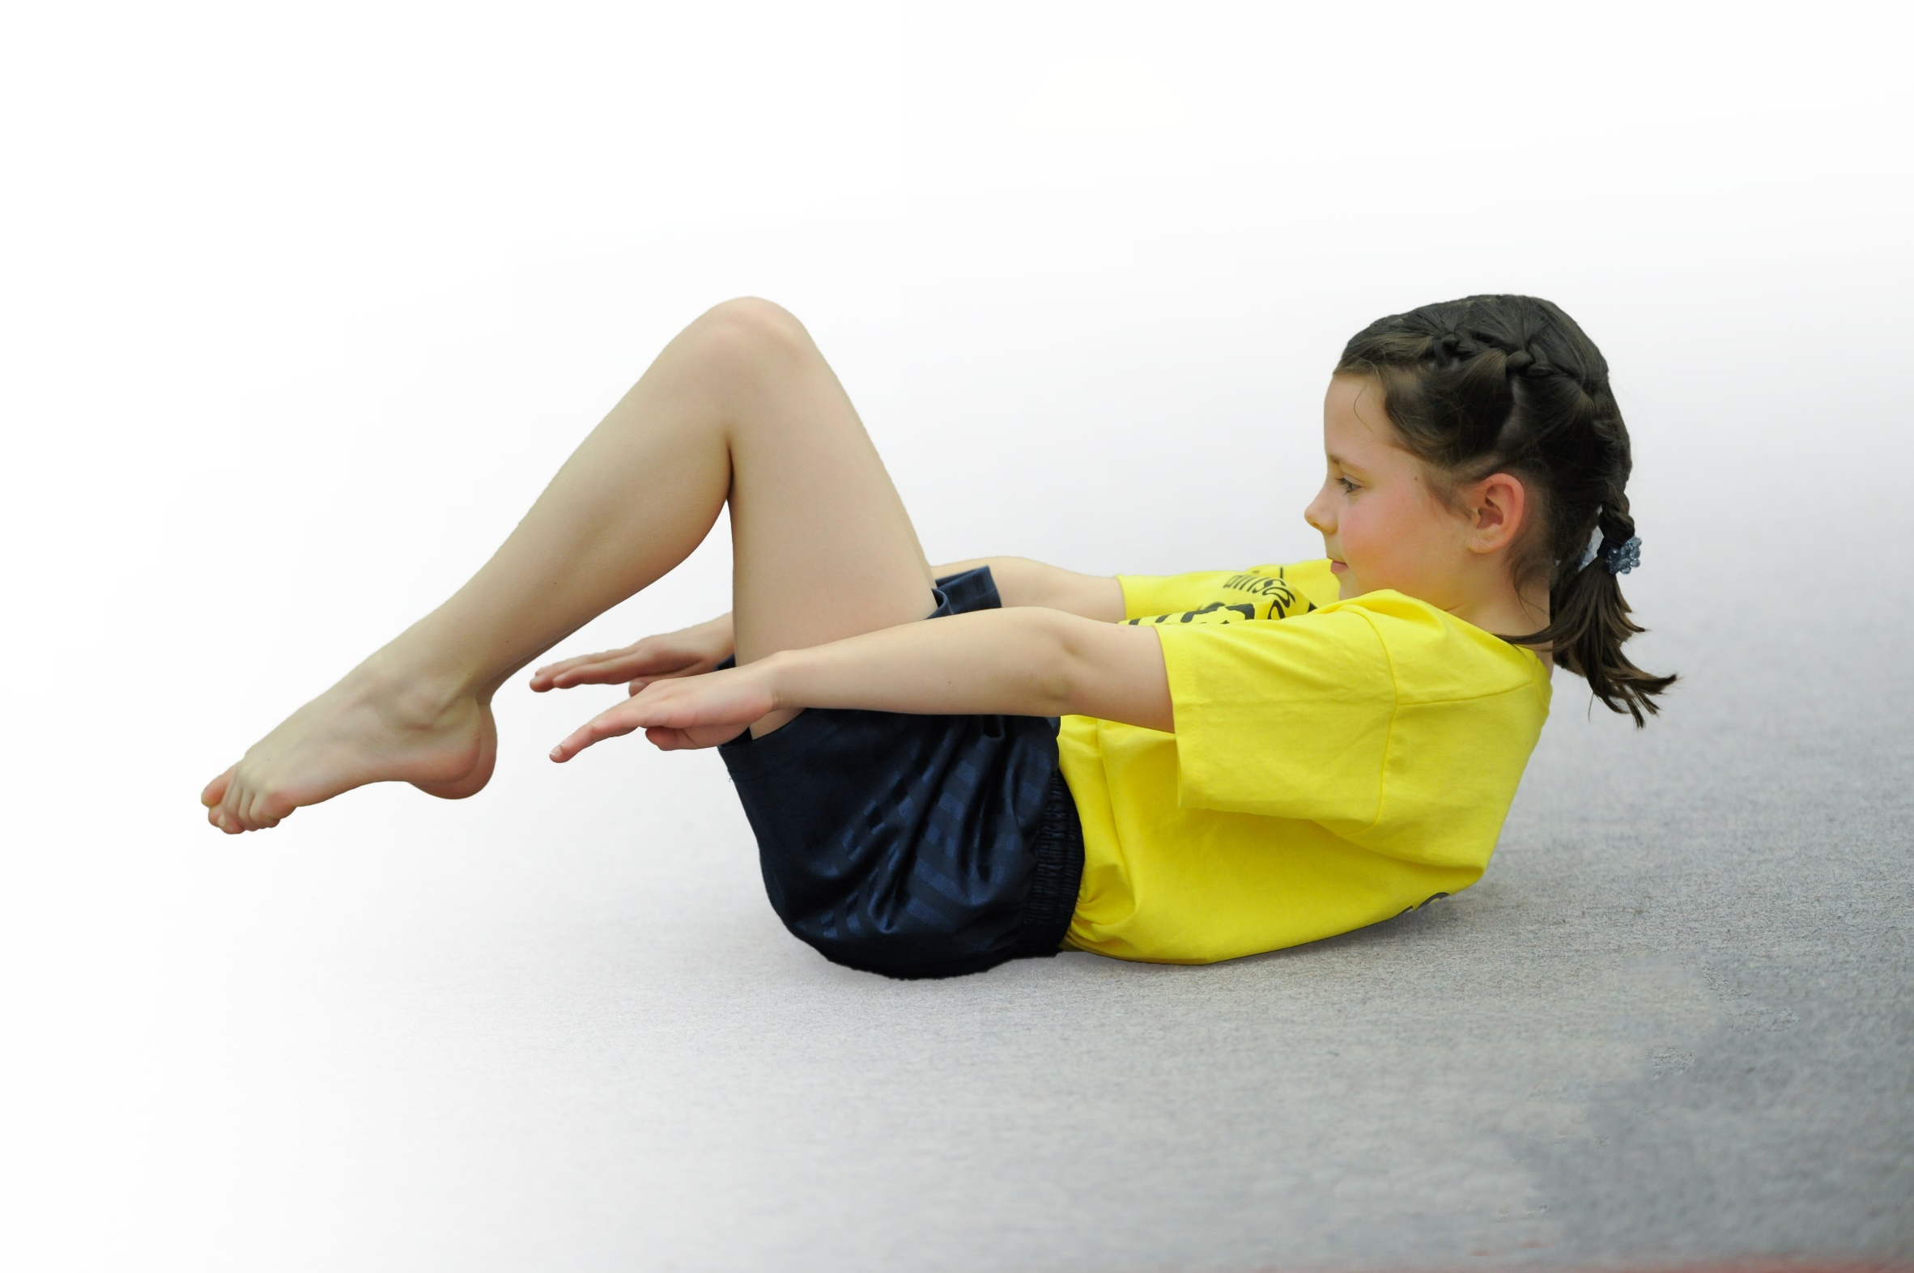
- build capacity and capability within the school to ensure that improvements made now will benefit pupils joining the school in future years

Please visit gov.uk for the revised DfE guidance including the 5 key indicators across which schools should demonstrate an improvement. This document will help you to review your provision and to report your spend. DfE encourages schools to use this template as an effective way of meeting the reporting requirements of the Primary PE and Sport Premium.

We recommend you start by reflecting on the impact of current provision and reviewing the previous spend.
Under the Ofsted Schools Inspection Framework, inspectors will assess how effectively leaders use
the Primary PE and Sport Premium and measure its impact on outcomes for pupils, and how effectively governors hold them to account
for this.

Schools are required to publish details of how they spend this funding as well as on the impact it has on pupils’ PE
and sport participation and attainment.
We recommend regularly updating the table and
publishing it on your website as evidence
of your ongoing review into how you are using the money
to secure maximum, sustainable impact. To see an example of how to complete the table please click HERE.

Support for review and reflection - considering the 5 key indicators from DfE, what development needs are a priority for your setting and your students now and why? Use the space below to reflect on previous spend, identify current need and priorities for the future.

Key achievements to date: | Areas for further improvement and baseline evidence of need:
- The engagement of all pupils in regular physical activity  - We continue to have 2 hours of PE curriculum time for all year groups  - UKS2 trained as Playground leaders and have ran games at playtimes  - Provision of Forest Schools, at least x1 per week  - Increased percentage of children with SEN participating in sporting events run by LSLSSP  - The profile of PE and sport is raised across the school as a tool for whole school improvement.  - Competitions are celebrated in celebration assemblies  - Sporting Events noticeboard in place  - Awarded Silver School Games Mark  - Increased use of Twitter to promote PE and sport involvement through a variety of events and activities  - Increased confidence, knowledge and skills of all staff in teaching PE and sport  - Sports TA updated weekly timetable of Playground activities and worked with Playground Leaders to run games at break times  - Broader experience of a range of sports and activities offered to all pupils  - Triathlon  - Range of after school clubs on offer to pupils  - All year groups have the opportunity to attend sporting events and festivals enabling all children to take part (inclusive of SEN).  - Visit from Kelvin Batey (BMX Champion)  - Increased participation in competitive sport  - Attending a wide variety of sporting events and competitions run by South Leicestershire SSP.  - An increase in the number of teams through to Level 2b finals.  - More sporting events represented.  - Increased percentage of children with SEN participating in sporting events run by LSLSSP | - The engagement of all pupils in regular physical activity  - PE Questionnaire – to see children’s participation in regular physical activity  - Increase participation in OSHL clubs  - Use of Sports Ambassadors to promote physical activity  - Participate in Virtual Competitions  - The profile of PE and sport is raised across the school as a tool for whole school improvement.  - To maintain current standing in School Games Mark and aim for Gold  - Increased participation in OSHL clubs  - Use Sporting Ambassadors to share information and promote PE in assemblies  - Increased confidence, knowledge and skills of all staff in teaching PE and sport  - Develop Assessment Framework for PE  - Develop Sports Coach  - Broader experience of a range of sports and activities offered to all pupils  - Create School Sports Group – made up of Sports Ambassadors  - Improve leadership percentages with KS2 children.  - Increased participation in competitive sport  - Maintain increase in uptake of competitions from SEN organised by SSP  - Arrange sporting events between partner school (Lubenham)

Meeting national curriculum requirements for swimming and water safety | Please complete all of the below*:
What percentage of your current Year 6 cohort swim competently, confidently and proficiently over a distance of at least 25 metres? | 100%  7 children in Yr 6
What percentage of your current Year 6 cohort use a range of strokes effectively [for example, front crawl, backstroke and breaststroke]? | 100%  7 children in Yr 6
What percentage of your current Year 6 cohort perform safe self-rescue in different water-based situations? | 100%  7 children in Yr 6
Schools can choose to use the Primary PE and Sport Premium to provide additional provision for swimming but this must be for activity over and above the national curriculum requirements. Have you used it in this way? | Yes/No
*Schools may wish to provide this information in April, just before the publication deadline.

Action Plan and Budget Tracking
Capture your intended annual spend against the 5 key indicators. Clarify the success criteria and evidence of impact that you intend to measure to evaluate for students today and for the future.

 | Academic Year: 2018/19 | Total fund allocated: £16, 860 | Date Updated: 29.9.19
 | Key indicator 1: The engagement of all pupils in regular physical activity – Chief Medical Officer guidelines recommend that primary school children undertake at least 30 minutes of physical activity a day in school
 | School focus with clarity on intended impact on pupils: | Actions to achieve: | Funding allocated: | Evidence and impact: | Sustainability and suggested next steps:
 | Taking advantage of more national initiatives to help promote fitness and physical activity: e.g. change4life, national fitness day and primary stars. | - Register for National Fitness Day (26.09.18)  - Work with Sports Ambassadors to decide on a whole school way to become involved, i.e. game/workout/going for a world record.  - Work with Sports TA, Sports Ambassadors and Sports School Council to plan events/activities to coincide with more national objectives, at least once a term. | No cost | - Whole of Yr 4, 5 and 6 trained to become Playground Leaders. A trio run a game each week.  - Sports Ambassadors were involved with an event/activity at least once a term. | - Continue to involve UKS2 in running Playground Games.  - Work with Sports Ambassadors/Leader and Sports Coach to plan events/activities to coincide with more national objectives, at least once a half term.
 | Promote daily physical activity which is not built into the school day for all pupils – national recommendation for 30 mins every day. | - Provision of Clubs (before school, lunch times and after school)  - Provide opportunities for chn to attend events, competitions and activities run out of school hours. | Part of the South Leicestershire School Partnership (£1750) | - Basketball Club with  - Si Sports Football Club with  - Si Sports Club with  - Cross Country Club with approx. 16 participants across KS2  - Competitions attended this year: Yr 5/6 Football League, U11 Table Tennis Tournament (Level 2 and 2b), Cross Country Races at Prestwold Hall and Harborough Leisure Centre (6 in total), Small School’s Danone Football Cup, Yr 3/4 Dodgeball Tournament, Yr 5/6 Dodgeball Tournament, Yr 5/6 Girls Football Tournament, Yr 5/6 Netball, Yr3/4 Quicksticks Tournament, Yr 5/6 Quicksticks Tournament, Yr3/4 Tennis Tournament, Yr5/6 Tennis Tournament, Yr 5/6 Rounders Tournament.  - Events attended this year:  Brownlee Foundation Mini-Triathlon (Yr 4, 5 and 6), Gifted and Talented Sessions at Lutterworth College and High School (x2 pupils), Sports Ambassadors Training (x3 pupils), TAG Rugby Festival  - Liaised with Mintridge Foundation who came for the day with Kelvin Batey (BMX Champion) | - Continue to provide a variety of clubs.  - Sports Coach to provide after school clubs  - Continue to enter a variety of competitions as provided by LSLSSP.  - Enter Virtual Competitions as provided by LSLSSP  - PE Questionnaire
Key indicator 2: The profile of PE and sport being raised across the school as a tool for whole school improvement
 | School focus with clarity on intended impact on pupils: | Actions to achieve: | Funding allocated: | Evidence and impact: | Sustainability and suggested next steps:
 | Reapply for School Games Mark. | - Look at the School Games Mark criteria for 2018/2019.  - Work with Sports TA, Sporting Ambassadors and Sports School Council to work towards criteria.  - Use assemblies to promote School Games Mark and its criteria for whole school to work towards.  - Use assemblies to update/feedback progress to children. | No cost | - Criteria looked at and printed off  - Awarded Silver | - Continue to promote the Schools Games Mark and aim for Gold.
 | Increased offer/participation in Out of  School Hours Learning (OSHL) clubs across KS1 and KS2 | - Invite clubs/sports groups to provide chn with a taster session  - Offer a variety of clubs/activities out of school hours for KS1 and KS2 to participate in.  - Promote clubs/ groups/achievements chn attend in Celebration assemblies. | Part of the South Leicestershire School Partnership (£1750) | - Hotshots Taster session at the start of the year  - Hotshots run tournaments/events outside of school  - Basketball Club (Hotshots) with  - Si Sports Football Club with  - Si Sports Club with  - Cross Country Club with approx. 16 participants across KS2  - Competitions attended this year: Yr 5/6 Football League, U11 Table Tennis Tournament (Level 2 and 2b), Cross Country Races at Prestwold Hall and Harborough Leisure Centre (6 in total), Small School’s Danone Football Cup, Yr 3/4 Dodgeball Tournament, Yr 5/6 Dodgeball Tournament, Yr 5/6 Girls Football Tournament  - Events attended this year:  Brownlee Foundation Mini-Triathlon (Yr 4, 5 and 6), Gifted and Talented Sessions at Lutterworth College and High School (x2 pupils), Sports Ambassadors Training (x3 pupils), TAG Rugby Festival  - Hotshots’ Player of the Half Term and Term Award presented in assemblies  - Competition certificates presented in assemblies  - PE Events board – displaying pictures from events/competitions | - Continue to provide a variety of clubs.  - Sports Coach to provide after school clubs  - Continue to enter a variety of competitions as provided by LSLSSP.  - Enter Virtual Competitions as provided by LSLSSP
 | Use Twitter to share information about sporting events, lessons and achievements. | - All classes have daily access to iPads with Twitter installed.  - Encourage teachers to tweet at least once a week.  - Tweet results/achievements of sporting events.  - Tweet pictures of sporting events/visitors/PE lessons/achievements/ trips, etc. | No cost | - Results from competitions posted on Twitter  - Pictures from events/competitions posted on Twitter  - Visit from Lutterworth College for the Playground Leaders Award, Brownlee Triathlon event - posted on Twitter  - Consecutive lessons from a former Leicester Tigers Rugby Player in preparation for a TAG Rugby Festival  - Pictures of PE lessons tweeted  - Staff who attend sporting events/competitions take an iPad with them | - Continue to share information regarding PE lessons and involvements in sporting events, activities, etc.

Key indicator 3: Increased confidence, knowledge and skills of all staff in teaching PE and sport
School focus with clarity on intended  impact on pupils: | Actions to achieve: | Funding  allocated: | Evidence and impact: | Sustainability and suggested  next steps:
Assessment Framework for PE needs developing | - Find an assessment format to suit both FS/KS1/KS2  - Inform those teaching PE in FS/KS1/KS2 of Assessment format  - Update O’Track half termly  - Review Assessment format | No cost | - Autumn 1 Trust Meeting’s Agenda – school’s to trial an assessment framework then review together – ongoing. | - Continue to explore ways to assess PE  - Use Sports Coach to assess across the school.
Develop Sports TA | - Meet fortnightly with Sports TA.  - Provide Sports TA with PE folder, containing letter templates and further information needed for sporting events and competitions.  - Sports TA to meet with Sports Ambassadors/Sports Council to plan and organise events in school. | No cost | - Communicate regularly with staff who teach PE – in terms of sports to be taught in preparation for competitions/events.  - Sports TA organises the trio running the Playground Game each week  - Sports TA organises the timetable display for the playground games/clubs | - Look to develop Sports Coach
Key indicator 4: Broader experience of a range of sports and activities offered to all pupils
School focus with clarity on intended  impact on pupils: | Actions to achieve: | Funding  allocated: | Evidence and impact: | Sustainability and suggested  next steps:
Additional achievements:  Create School Sports Council | - Form a Sports Council involving Sports Ambassadors and Captains  - During Sports Council meetings organise and plan sporting events for the chn to run and lead to the rest of the school | Part of the South Leicestershire School Partnership (£1750) | - Sports Ambassador and Captain Roles assigned.  - Whole of Yr 4, 5 and 6 trained to become Playground Leaders. A trio run a game each week.  - Sport Ambassadors attended training at Lutterworth High School  - Met with Sports Ambassadors to arrange a small number of events. | - Create School Sports Group made up of Sports Ambassadors/Leader and meet at least once per half term to discuss sport within the school and upcoming events.
Improve leadership percentages with KS2 children. | - Assign Sports Ambassador/Sports Captain roles to Yr5/6 chn  - Form a Sports Council involving Sports Ambassadors and Captains  - Sports Ambassadors to attend training at Lutterworth High School  - During Sports Council meetings organise and plan sporting events for the chn to run and lead to the rest of the school | Part of the South Leicestershire School Partnership (£1750) | - Sports Ambassador and Captain Roles assigned.  - Whole of Yr 4, 5 and 6 trained to become Playground Leaders. A trio run a game each week.  - Sport Ambassadors attended training at Lutterworth High School  - Met with Sports Ambassadors to arrange a small number of events. | - Continue to improve promote leadership percentages with KS2 children.
Key indicator 5: Increased participation in competitive sport
School focus with clarity on intended  impact on pupils: | Actions to achieve: | Funding  allocated: | Evidence and impact: | Sustainability and suggested  next steps:
Need to increase uptake of competitions for SEN organised by SSP | - Provide chn with SEN with the opportunity to attend sporting events organised by the SSP | Part of the South Leicestershire School Partnership (£1750) | - Chn with SEN have attended sporting events organised by the SSP (but these have not been specifically for chn with SEN) | - Continue to invite chn with SEN to sporting events, activities, etc.
Take more B teams to SSP events | - Send out a sufficient amount of letters for a B team.  - Arrange PE lessons to coincide with sporting events so all chn have experience of the event to promote more participation in sporting events. | Part of the South Leicestershire School Partnership (£1750) | - A B team has been arranged for the following events: Yr5/6 Basketball, Yr5/6 Dodgeball, U11 Team Table Tennis  - PE lessons have been arranged to coincide with competitions/events. | - Continue to take an A and B team where appropriate.
Attend local cluster events | - Register for local events via the SSP website.  - Arrange transport. | Part of the South Leicestershire School Partnership (£1750) | - TAG Rugby Festival  - Market Harborough Cross Country Races | - Continue to attend local cluster events.  - Arrange sporting events between partner school (Lubenham)
Total cost |  |  |  | £ 16 860

