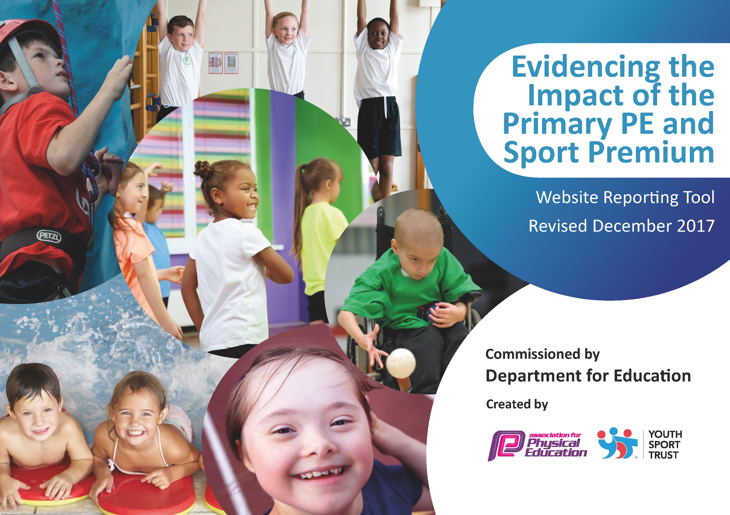

Schools must use the funding to make additional and sustainable improvements to the quality of PE and sport they offer. This means that you should use the Primary PE and Sport Premium to:

- develop or add to the PE and sport activities that your school already offers
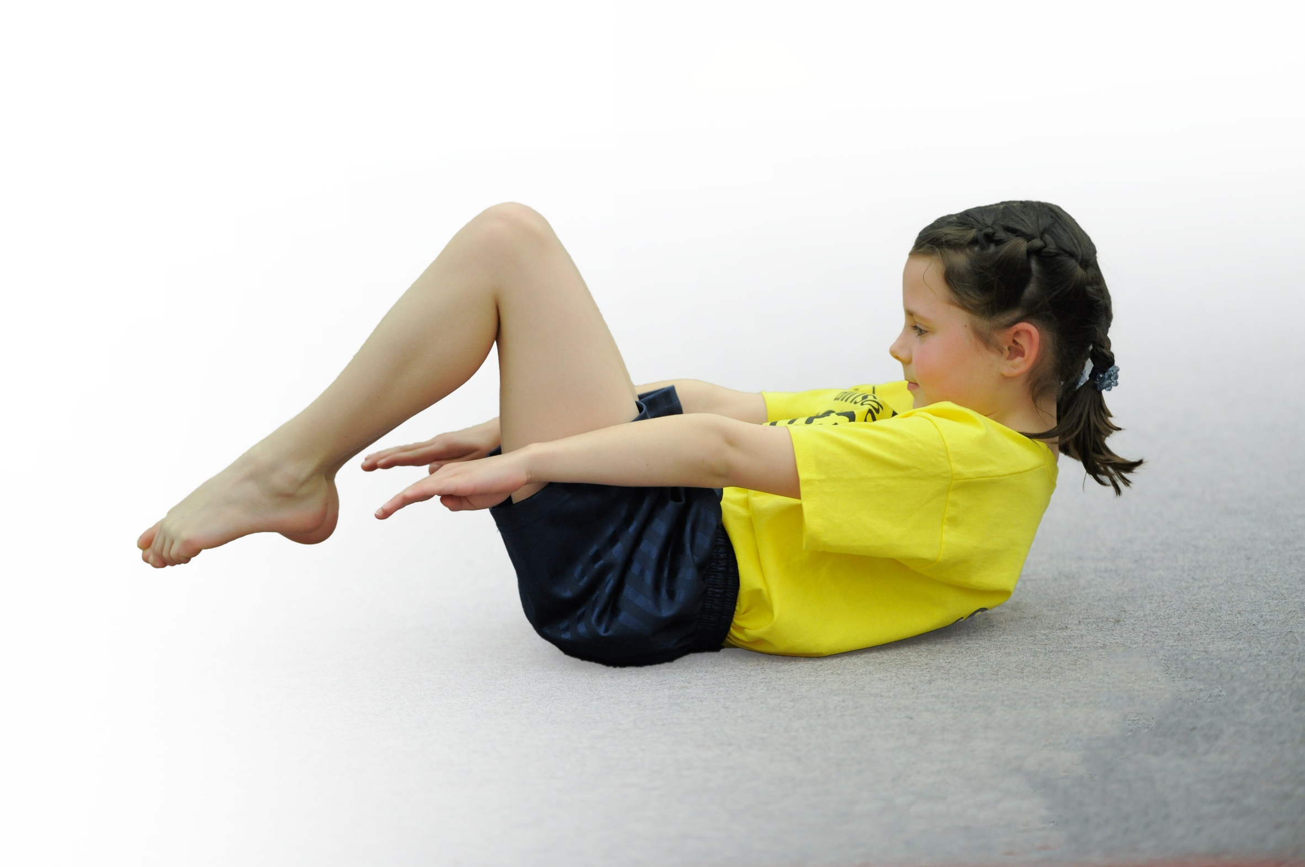
- build capacity and capability within the school to ensure that improvements made now will benefit pupils joining the school in future years

Please visit gov.uk for the revised DfE guidance including the 5 key indicators across which schools should demonstrate an improvement. This document will help you to review your provision and to report your spend. DfE encourages schools to use this template as an effective way of meeting the reporting requirements of the Primary PE and Sport Premium.

We recommend you start by reflecting on the impact of current provision and reviewing the previous spend.
Under the Ofsted Schools Inspection Framework, inspectors will assess how effectively leaders use
the Primary PE and Sport Premium and measure its impact on outcomes for pupils, and how effectively governors hold them to account
for this.

Schools are required to publish details of how they spend this funding as well as on the impact it has on pupils’ PE
and sport participation and attainment.
We recommend regularly updating the table and
publishing it on your website as evidence
of your ongoing review into how you are using the money
to secure maximum, sustainable impact. To see an example of how to complete the table please click HERE.

Support for review and reflection - considering the 5 key indicators from DfE, what development needs are a priority for your setting and your students now and why? Use the space below to reflect on previous spend, identify current need and priorities for the future.

Key achievements to date: | Areas for further improvement and baseline evidence of need:
- The engagement of all pupils in regular physical activity  - Participated in Virtual Competitions  - Yr 1, 3 and 5 participated in the Active Lives Child Survey and received a report analysing the children’s responses  - Increased participation in OSHL clubs  - Used Sports Ambassadors to promote physical activity  - Response to COVID-19: Provided children with suggested activities and resources to use during lockdown to promote regular physical activity, i.e. Joe Wicks, Sports Coach created films to upload onto Facebook page  - The profile of PE and sport is raised across the school as a tool for whole school improvement.  - Maintained current standing in School Games Mark  - Increased participation in OSHL clubs  - Used Sporting Ambassadors to share information and promote PE in assemblies  - Increased confidence, knowledge and skills of all staff in teaching PE and sport  - Developed Sports Coach  - Broader experience of a range of sports and activities offered to all pupils  - Liaised regularly with Sports Ambassadors and Sports Coach  - Rec/Yr 1 participated in the BIG Moves workshop and were assessed before and after to evaluate impact; data analysis report was provided  - SEN children were identified and social and gross motor skills intervention was provided by Sports Coach  - Increased participation in competitive sport  - Maintain increase in uptake of competitions from SEN organised by SSP  - Arranged an inter-school football tournament between partner school (Lubenham) | - The engagement of all pupils in regular physical activity  - PE Questionnaire – to see children’s participation in regular physical activity and assess wellbeing  - Provide and promote regular physical activity opportunities following COVID-19 guidance, i.e. virtual competitions, OSHL clubs  - Develop the role of Wellbeing Ambassadors  - Use of Sports Coach and Sports Ambassadors to promote physical activity, increase their role in assemblies  - The profile of PE and sport is raised across the school as a tool for whole school improvement.  - To maintain current standing in School Games Mark and aim for Gold  - Adapt current provision of PE to coincide with COVID-19 guidance  - Use Sporting Ambassadors to share information and promote PE in virtual assemblies  - Share children’s sporting achievements in assemblies and via social media  - Promote mental health and wellbeing, i.e. develop the role of Wellbeing Ambassadors, inserts in Newsletters.  - Increased confidence, knowledge and skills of all staff in teaching PE and sport  - Ensure all staff are familiar with COVID-19 guidance for PE and follow the guidelines in the delivery of lessons and clubs.  - Develop Assessment Framework for PE  - Develop Sports Coach to undertake a leading role in PE across the school  - Broader experience of a range of sports and activities offered to all pupils  - Improve leadership percentages with KS2 children through Sporting Ambassadors and Wellbeing Ambassadors  - Provide activities for targeted groups  - Increased participation in competitive sport  - Involve all year groups in participating in a Virtual Competition during the year  - Continue to arrange sporting events between partner schools (Lubenham and South Kilworth)

Meeting national curriculum requirements for swimming and water safety | Please complete all of the below*:
What percentage of your current Year 6 cohort swim competently, confidently and proficiently over a distance of at least 25 metres?
What percentage of your current Year 6 cohort use a range of strokes effectively [for example, front crawl, backstroke and breaststroke]?
What percentage of your current Year 6 cohort perform safe self-rescue in different water-based situations?
Schools can choose to use the Primary PE and Sport Premium to provide additional provision for swimming but this must be for activity over and above the national curriculum requirements. Have you used it in this way? | Yes/No
*Schools may wish to provide this information in April, just before the publication deadline.

Due to COVID-19, we were unable to conduct a survey in the Spring Term to identify the most up-to-date responses to the above national requirements.

Action Plan and Budget Tracking
Capture your intended annual spend against the 5 key indicators. Clarify the success criteria and evidence of impact that you intend to measure to evaluate for students today and for the future.

Academic Year: 2019/2020 | Total fund allocated: £16,540 | Date Updated: 27.9.20
Key indicator 1: The engagement of all pupils in regular physical activity – Chief Medical Officer guidelines recommend that primary school children undertake at least 30 minutes of physical activity a day in school |  |  |  | Percentage of total allocation:
 |  |  |  | 99.2%
School focus with clarity on intended impact on pupils: | Actions to achieve: | Funding allocated: | Evidence and impact: | Sustainability and suggested next steps:
Participate in Virtual Competitions organised by LSLSSP | - Participate in a Virtual competition at least x1 per term.  - Involve Sports Ambassadors and Sports Coach in promoting and collecting data for the Virtual Competitions. | £2600 – LSLSSP Package  £13,806 – Sports Coach | - Children in UKS2 participated in 2 virtual challenges (Autumn 2 and Spring 1). We were unable to participate in more due to COVID-19  - Sports Ambassadors were involved in running and scoring the second virtual challenge | - Continue to participate in virtual competitions run by the partnership  - Continue to involve Sports Ambassadors in running Virtual Competitions.  - Include other year groups across the school in virtual competitions - use sports coach to help with this
Develop Sporting Ambassadors role within school to involve pupils in improving our physical activity levels at school. | - Identify Sporting Ambassadors  - Children to plan activities to increase physical activity at school and use assembly times to promote events/activities, i.e. Virtual Competitions. | £2600 – LSLSSP Package  £13,806 – Sports Coach | - 4 children were trained as Sports Ambassadors through the LSLSSP  - Sports Ambassadors were involved in running and scoring the second virtual challenge  - Sports Ambassadors were involved with sharing information about the Virtual Challenges in assemblies | - Continue to train children to become Sports Ambassadors  - Continue to involve Sports Ambassadors in running events/activities/competitions and promoting them in assemblies - use sports coach to help with this
Conduct a PE Questionnaire | - Across school, chn to answer a PE Questionnaire to establish engagement of all pupils in regular exercise.  - Conduct a PE Questionnaire in the Autumn and Summer term. | No cost | - In the Autumn term, Yr 1, 3 and 5 participated in the Active Lives Child Survey and received a report based on the cohorts’ responses.  - Unable to conduct a PE Questionnaire in the Summer Term due to COVID-19 | - Continue to conduct surveys to assess children’s engagement in regular exercise and attitudes towards PE
Increase participation in physical activity of less active pupils | - Conduct PE Questionnaire to identify less active pupils  - Provide opportunities for these chn to increase their physical activity | £2600 – LSLSSP Package  £13,806 – Sports Coach | - Rec/Yr 1 participated in the Big Moves workshop run by the LSLSSP which focused on developing children’s physical literacy skills. Children were assessed before and after the workshop to evaluate impact; provided with a data analysis report.  - SEN children were identified and social and gross motor skills intervention was provided by Sports Coach | - Continue to participate in workshops run by the LSLSSP to impact children’s physical activity  - Continue to use Sports Coach for focused intervention
Key indicator 2: The profile of PE and sport being raised across the school as a tool for whole school improvement |  |  |  | Percentage of total allocation:
 |  |  |  | 99.2%
School focus with clarity on intended impact on pupils: | Actions to achieve: | Funding allocated: | Evidence and impact: | Sustainability and suggested next steps:
Use Sports Ambassadors to promote PE | - Sports Ambassadors to use assembly times to promote Sporting events/activities in school.  - Sports Ambassadors to help in the running of Virtual Competitions. | £2600 – LSLSSP Package  £13,806 – Sports Coach | - 4 children were trained as Sports Ambassadors through the LSLSSP  - Sports Ambassadors were involved in running and scoring the second virtual challenge  - Sports Ambassadors were involved with sharing information about the Virtual Challenges in assemblies | - Continue to train children to become Sports Ambassadors  - Continue to involve Sports Ambassadors in running events/activities/competitions and promoting them in assemblies - use sports coach to help with this
Develop Assessment Framework in PE | - Find a suitable and appropriate Assessment Framework to be used in PE  - Assessments for PE to be collected at least once per term. | No cost | - Employed Sports Coach and focused on induction training and the delivery of lessons. Need to trial an assessment framework when Sports Coach is familiar with school ethos and then review together – ongoing. | - Continue to explore ways to assess PE  - Use Sports Coach to assess across the school.
Maintain standard in Schools Games Mark and aim for Gold | - Collect data and evidence required throughout the year  - Understand School Games Mark criteria  - Submit application  - Share and promote Schools Games Mark in school and with parents | No cost | - Due to COVID-19, the School Games Mark made the decision to pause the award and roll over the status given in the previous academic year.  - The LSLSSP alternatively invited members to send them 2 paragraphs detailing the sport and physical activity opportunities provided before and during lockdown.  - Continued to update the Sports board and shared details of events/achievements in assemblies. | - Continue to promote the Schools Games Mark and aim for Gold.

Key indicator 3: Increased confidence, knowledge and skills of all staff in teaching PE and sport |  |  |  | Percentage of total allocation:
 |  |  |  | 99.2%
School focus with clarity on intended  impact on pupils: | Actions to achieve: | Funding  allocated: | Evidence and impact: | Sustainability and suggested  next steps:
Develop Sports Coach | - Provision of Units of Work to follow for PE lessons  - Meet with Sports Coach on a regular basis  - Monitor and coach Sports Coach to develop their own CPD  - Sports coach to liaise with Sports Ambassadors  - Sports Coach to represent/attend some of the competitions organised by LSLSSP | £13,806 – Sports Coach | - Lessons follow the Val Sabin scheme  - Worked alongside HOS in coaching the Sports Coach and met on a regular basis  - Sports Coach was involved with liaising with Sports Ambassadors and ran games/activities at playtimes  - Sports Coach led and ran afterschool clubs  - Sports Coach attended some of the competitions organised by the LSLSSP and was involved with the organisiation and running (alongside the HOS) of an inter-school football tournament with Lubenham All Saints Primary | - Continue to work alongside th HOS to develop the Sports Coach further through coaching  - Use the Sports Coach to develop an Assessment Framework for PE  - Continue to use the Sports coach in delivering afterschool clubs  - Continue to use the Sports Coach to organise and run intra-competitions between year groups and inter-competitions between local schools
Develop Assessment Framework in PE | - Find a suitable and appropriate Assessment Framework to be used in PE  - Assessments for PE to be collected at least once per term. | No cost | - Employed Sports Coach and focused on induction training and the delivery of lessons. Need to trial an assessment framework when Sports Coach is familiar with school ethos and then review together – ongoing. | - Continue to explore ways to assess PE  - Use Sports Coach to assess across the school.
Key indicator 4: Broader experience of a range of sports and activities offered to all pupils |  |  |  | Percentage of total allocation:
 |  |  |  | 99.2%
School focus with clarity on intended  impact on pupils: | Actions to achieve: | Funding  allocated: | Evidence and impact: | Sustainability and suggested  next steps:
Increase offer and participation in OSHL clubs | - Sports Coach to run a variety of after school clubs  - Promote the clubs on offer in school | £13,806 – Sports Coach | - Sports Coach led and ran afterschool clubs  - Sports Coach surveyed children termly to determine the clubs to be offered to spark interest | - Continue to use the Sports coach in delivering afterschool clubs
Participate in Virtual Competitions organised by LSLSSP | - Participate in a Virtual competition at least x1 per term.  - Involve Sports Ambassadors and Sports Coach in promoting and collecting data for the Virtual Competitions. | £2600 – LSLSSP Package  £13,806 – Sports Coach | - Children in UKS2 participated in 2 virtual challenges (Autumn 2 and Spring 1). We were unable to participate in more due to COVID-19  - Sports Ambassadors were involved in running and scoring the second virtual challenge | - Continue to participate in virtual competitions run by the partnership  - Continue to involve Sports Ambassadors in running Virtual Competitions.  - Include other year groups across the school in virtual competitions - use sports coach to help with this
Create School Sports Group | - Meet regularly with Sporting Ambassadors and Sports Coach  - Use Sporting Ambassadors to promote PE in assemblies  - Use Sporting Ambassadors to help promote/run sporting events/activities in school  - Meet at least once per half term | £2600 – LSLSSP Package  £13,806 – Sports Coach | - 4 children were trained as Sports Ambassadors through the LSLSSP  - Sports Ambassadors were involved in running and scoring the second virtual challenge  - Sports Ambassadors were involved with sharing information about the Virtual Challenges in assemblies  - Met at least once per half term | - Continue to train children to become Sports Ambassadors  - Continue to involve Sports Ambassadors in running events/activities/competitions and promoting them in assemblies - use sports coach to help with this
Target less active pupils | - Conduct PE Questionnaire to identify less active pupils  - Provide opportunities for these chn to increase their physical activity – i.e. Change4Life Festival | No cost | - In the Autumn term, Yr 1, 3 and 5 participated in the Active Lives Child Survey and received a report based on the cohorts’ responses.  - Unable to conduct a PE Questionnaire in the Summer Term due to COVID-19  - Rec/Yr 1 participated in the Big Moves workshop run by the LSLSSP which focused on developing children’s physical literacy skills. Children were assessed before and after the workshop to evaluate impact; provided with a data analysis report.  - SEN children were identified and social and gross motor skills intervention was provided by Sports Coach | - Continue to conduct surveys to assess children’s engagement in regular exercise and attitudes towards PE  - Continue to participate in workshops run by the LSLSSP to impact children’s physical activity  - Continue to use Sports Coach for focused intervention
Key indicator 5: Increased participation in competitive sport |  |  |  | Percentage of total allocation:
 |  |  |  | 99.2%
School focus with clarity on intended  impact on pupils: | Actions to achieve: | Funding  allocated: | Evidence and impact: | Sustainability and suggested  next steps:
Arrange sporting events/competitions between partner school (Lubenham) | - Sports Coaches from both schools to meet/email at least once per term to arrange an event/competition between the two schools. | £13,806 – Sports Coach | - Sports Coach was involved with the organisiation and running (alongside the HOS) of an inter-school football tournament with Lubenham All Saints Primary | - Continue to use the Sports Coach to organise and run intra-competitions between year groups and inter-competitions between local schools
Target Year 1 and 2 pupils to take part in more competitive sport opportunities | - Identify events for Yr1/2 pupils  - Celebrate participation through assemblies or twitter | £2600 – LSLSSP Package | - Due to COVID-19, many of the competitions/events were cancelled and we were unable to participate  - Rec/Yr 1 participated in the Big Moves workshop run by the LSLSSP which focused on developing children’s physical literacy skills. Children were assessed before and after the workshop to evaluate impact; provided with a data analysis report. | - Continue to involve and promote sport opportunities and competitions to KS1, i.e. Virtual competitions
Other Costs funded by the Sports Premium Budget:
Resources - £64.00
Remaining balance - £70.00

