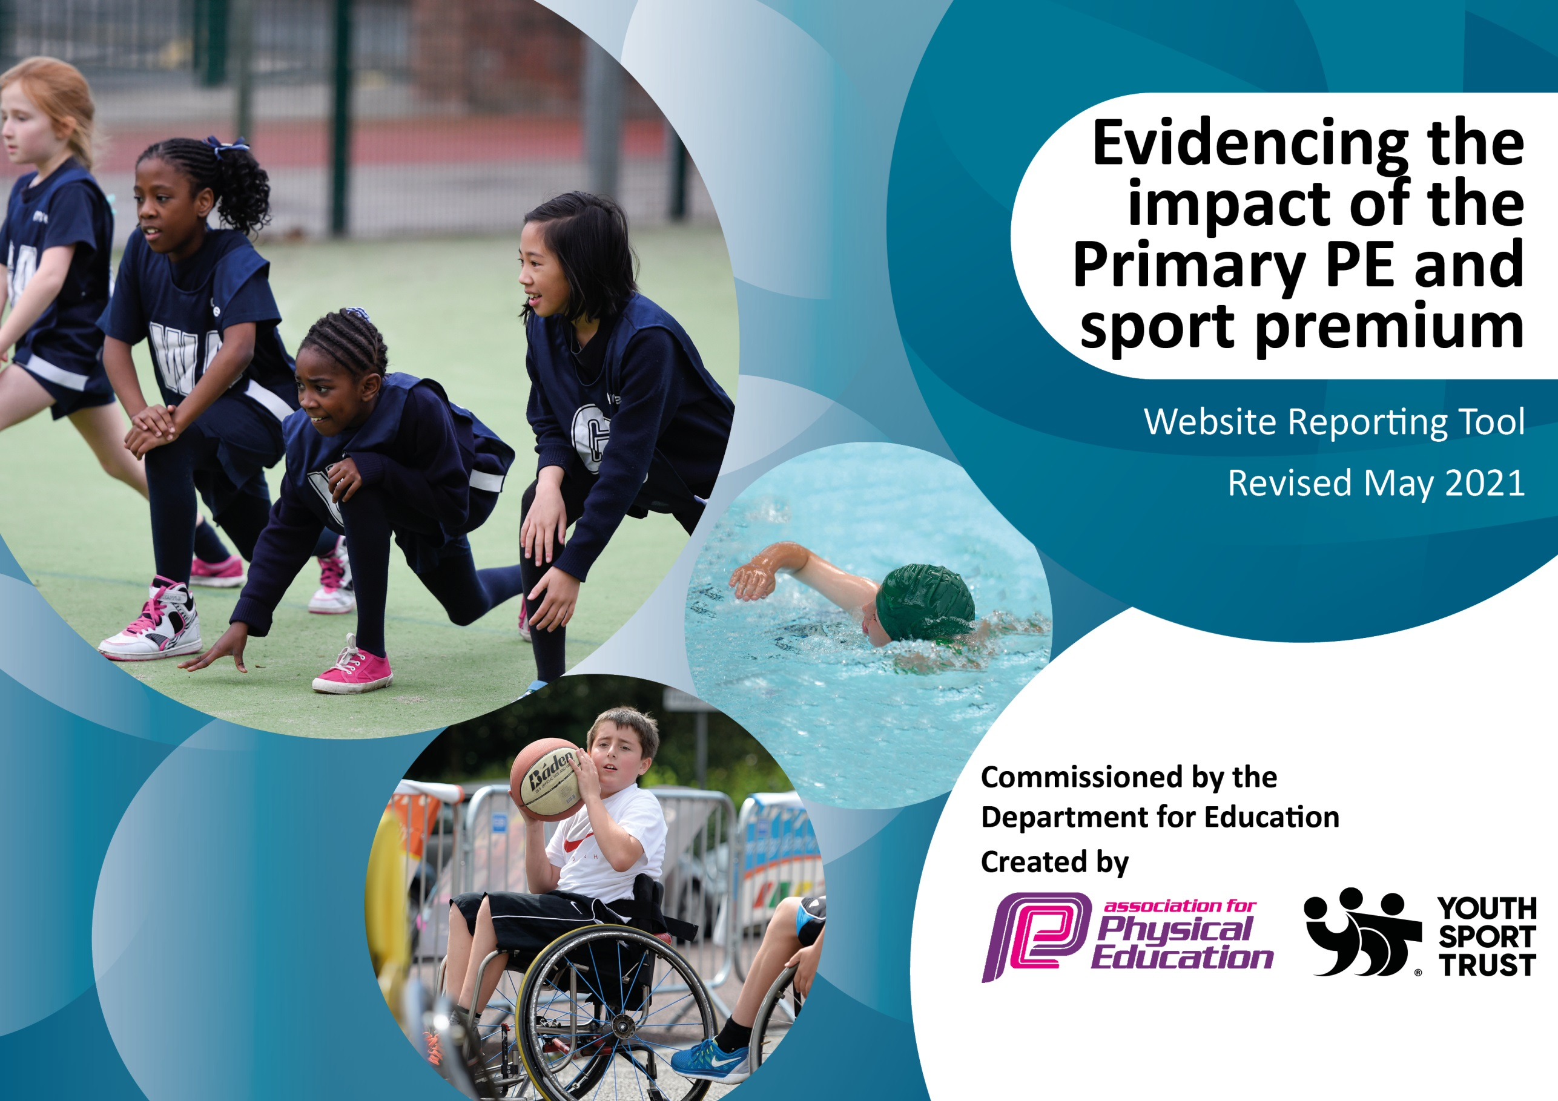

It is important that your grant is used effectively and based on school need. The Education Inspection Framework (Ofsted 2019 p64) makes clear there will be a focus on ‘whether leaders and those responsible for governors all understand their respective roles and perform these in a way that enhances the effectiveness of the school’.

Under the Quality of Education criteria (p41) inspectors consider the extent to which schools can articulate their curriculum (INTENT), construct their curriculum (IMPLEMENTATION) and demonstrate the outcomes which result (IMPACT).

To assist schools with common transferable language this template has been developed to utilise the same three headings which should make your plans easily transferable between working documents.

Schools must use the funding to make additional and sustainable improvements to the quality of Physical Education, School Sport and Physical Activity (PESSPA) they offer. This means that you should use the Primary PE and sport premium to:

- Develop or add to the PESSPA activities that your school already offer
- Build capacity and capability within the school to ensure that improvements made now will benefit pupils joining the school in future years
- The Primary PE and sport premium should not be used to fund capital spend projects; the school’s budget should fund these.
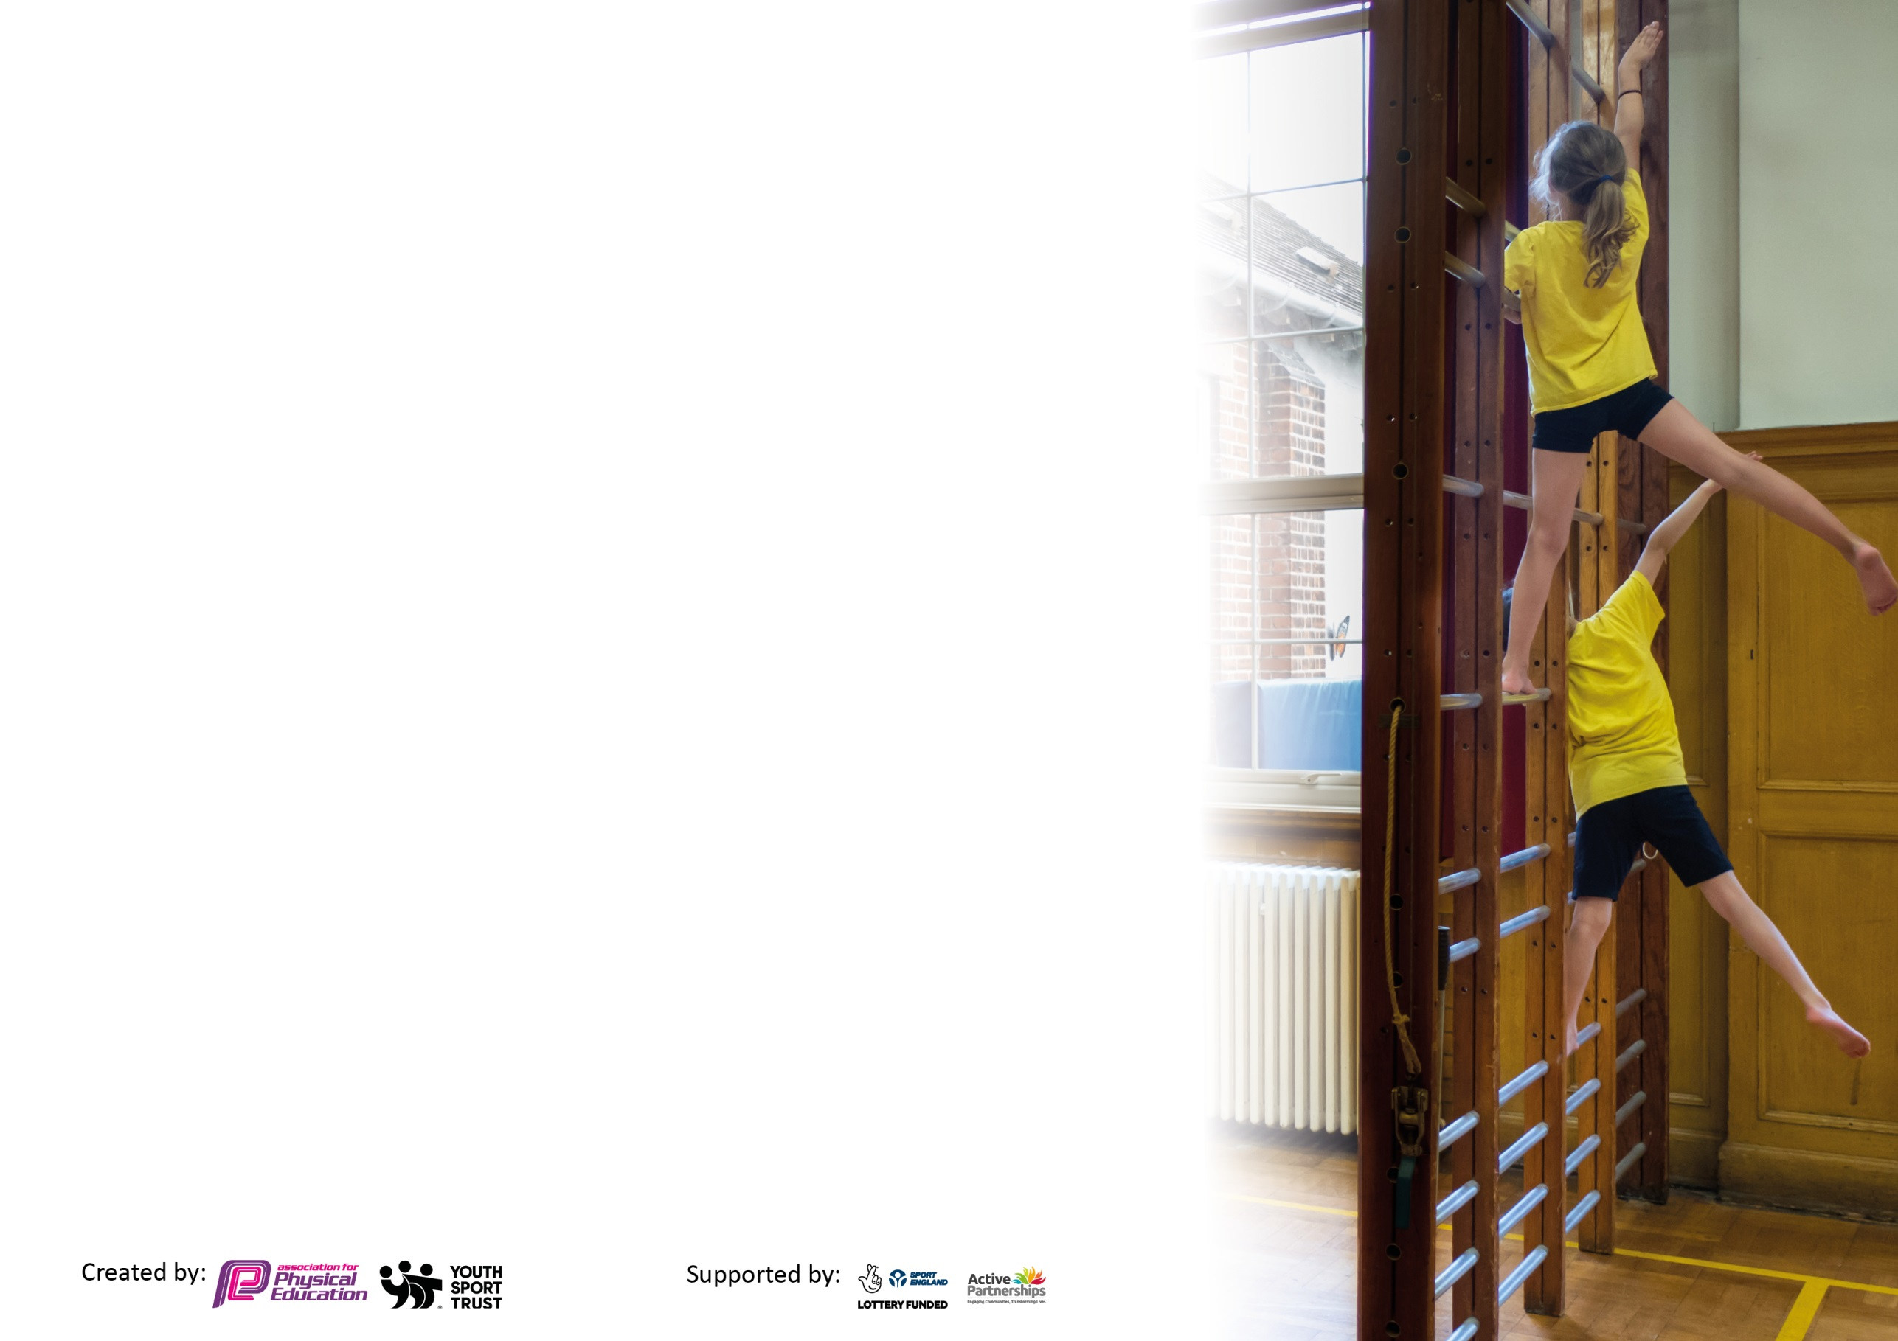
Please visit gov.uk for the revised DfE guidance including the 5 key indicators across which schools should demonstrate an improvement. This document will help you to review your provision and to report your spend. DfE encourages schools to use this template as an effective way of meeting the reporting requirements of the Primary PE and sport premium.

We recommend you start by reflecting on the impact of current provision and reviewing the previous spend.

Schools are required to publish details of how they spend this funding, including any under-spend from 2019/2020, as well as on the impact it has on pupils’ PE and sport participation and attainment by the end of the summer term or by 31st July 2021 at the latest.

We recommend regularly updating the table and publishing it on your website throughout the year. This evidences your ongoing self-evaluation of how you are using the funding to secure maximum, sustainable impact. Final copy must be posted on your website by the end of the academic year and no later than the 31st July 2021. To see an example of how to complete the table please click HERE.



Please note: Although there has been considerable disruption in 2020 it is important that you publish details on your website of how you spend the funding - this is a legal requirement.
Support for review and reflection - considering the 5 key indicators from DfE, what development needs are a priority for your setting and your pupils now and why? Use the space below to reflect on previous spend and key achievements and areas for development.

N.B. In this section you should refer to any adjustments you might have made due to Covid-19 and how these will influence further improvement.
Key achievements to date until July 2020: | Areas for further improvement and baseline evidence of need:
- The engagement of all pupils in regular physical activity  - Participated in Virtual Competitions, each class have competed in at least one throughout the course of the year.  - Targeted less active, less confident and SEN children who have all enjoyed the sessions.  - BIG Moves saw an improvement rate of 90% across a 6-week period  - During remote learning, provide suggestions for chn to keep active at home.  - Conducted PE Questionnaire in Summer Term  - The profile of PE and sport is raised across the school as a tool for whole school improvement.  - Offered a range of OSHL clubs  - Promoted Virtual Competitions and activities across the school  - Participated in Active Travel Month  - Shared Sports Day and other sprots related activity with parents via social media  - Increased confidence, knowledge and skills of all staff in teaching PE and sport  - Begun to develop the role of Sports Coach  - Beginning to form a collaborative relationship between the three small schools in the leadership of PE (STA, LAS, SK)  - Broader experience of a range of sports and activities offered to all pupils  - Rec/Yr 1 participated in the BIG Moves workshop and were assessed before and after to evaluate impact; data analysis report was provided  - SEN children and less active chn participated in a 6-week Inclusive Programme, all thoroughly enjoyed the sessions and continued to play the games at break times.  - Less active and less confident chn participated in a 6-week Energise Programme, all thoroughly enjoyed the sessions and continued to play the games at break times.  - Whole school enjoyed an African Drum and Dance Workshop in the Summer Term  - Increased participation in competitive sport  - Participated in a number of competitions and events run by the LSLSSP  - Arranged an intra-school sports day which the whole school participated in and was enjoyed by all chn. | - The engagement of all pupils in regular physical activity  - PE Questionnaire – use the results to inform action plan for next academic year and then reassess the chn at different points during the year.  - Focus on encouraging all chn to be active for at least 60 minutes per day  - Promote and encourage an increase in participation at OSHL clubs  - Use of Sports Coach and Sports Ambassadors to promote physical activity, increase their role in assemblies  - The profile of PE and sport is raised across the school as a tool for whole school improvement.  - To maintain current standing in School Games Mark and aim for Gold  - Develop the role of Sports Coach  - Use Sporting Ambassadors to share information and promote PE in virtual assemblies  - Share children’s sporting achievements in assemblies and via social media  - Work collaboratively with PE co-ordinators from LAS/SK to develop the profile of PE and devise an Assessment Framework  - Continue to promote mental health and wellbeing, i.e. develop the role of Wellbeing Ambassadors, inserts in Newsletters.  - Increased confidence, knowledge and skills of all staff in teaching PE and sport  - Develop Assessment Framework for PE  - Develop Sports Coach to undertake a leading role in PE across the school  - Provide opportunities for staff especially Sports Coach to develop CPD  - Broader experience of a range of sports and activities offered to all pupils  - Attend competitions and events run by LSLSSP  - Provide opportunities for chn to try new sports/activities or meet with visitors to inspire physical activity  - Provide activities for targeted groups  - Increased participation in competitive sport  - Involve all year groups in participating in a physical activity/competition each term  - Continue to arrange sporting events between partner schools (Lubenham and South Kilworth)

Did you carry forward an underspend from 2019-20 academic year into the current academic year? NO
Total amount carried forward from 2019/2020 £0
+ Total amount for this academic year 2020/2021 £16,500
= Total to be spent by 31st July 2021 £13,800

Meeting national curriculum requirements for swimming and water safety.  N.B Complete this section to your best ability. For example you might have practised safe self-rescue techniques on dry land which you can transfer to the pool when school swimming restarts.  Due to exceptional circumstances priority should be given to ensuring that pupils can perform safe self rescue even  if they do not fully meet the first two requirements of the NC programme of study. | Year 6 cohort consists of 5 children
What percentage of your current Year 6 cohort swim competently, confidently and proficiently over a distance of at least 25 metres?  N.B. Even though your pupils may swim in another year please report on their attainment on leaving primary school at the end of the summer term 2021.  Please see note above. | 100%
What percentage of your current Year 6 cohort use a range of strokes effectively [for example, front crawl, backstroke and breaststroke]?  Please see note above. | 100%
What percentage of your current Year 6 cohort perform safe self-rescue in different water-based situations? | 40%
Schools can choose to use the Primary PE and sport premium to provide additional provision for swimming but this must be for activity over and above the national curriculum requirements. Have you used it in this way? | No

Action Plan and Budget Tracking
Capture your intended annual spend against the 5 key indicators. Clarify the success criteria and evidence of impact that you intend to measure to evaluate for pupils today and for the future.

Academic Year: 2020/21 | Total fund allocated: £16,500 | Date Updated: 6.7.21
Key indicator 1: The engagement of all pupils in regular physical activity – Chief Medical Officers guidelines recommend that primary school pupils undertake at least 30 minutes of physical activity a day in school |  |  |  | Percentage of total allocation:
 |  |  |  | %
Intent | Implementation |  | Impact
Your school focus should be clear what you want the pupils to know and be able to do and about  what they need to learn and to  consolidate through practice: | Make sure your actions to achieve are linked to your intentions: | Funding allocated: | Evidence of impact: what do pupils now know and what can they now do? What has changed?: | Sustainability and suggested next steps:
Maintain Option 1 Membership with Learning South Leicestershire School Sports Partnership (LSLSSP) | - Renew membership  - Partake in events and competitions run by the LSLSSP offered as part of Option 1  - Partake in CPD opportunities and attend Subject Lead Meetings | £2700 (South Leicestershire SSP Membership) | - Membership renewed and participated in opportunities provided by LSLSSP  - PE Subject Leader Meetings attended half termly, PE Co-Ordinator shared information with the relevant member so staff and shared events/competitions across the school  - Shared opportunities for CPD with Sports Coach  - Participated in a number of events and competitions run by the LSLSSP, which are outlined in this document. | - Renew membership for next academic year  - Focus on encouraging less-active children to participate in opportunities or events/competitions offered by LSLSSP  - Aim to encourage chn to be active for at least 60 minutes everyday
Provide and promote regular physical activity opportunities that follow COVID-19 guidance | - Ensure all children can engage in x2 PE lessons a week which are COVID compliant  - Offer OSHL clubs which are COVID compliant  - Partake in virtual competitions and activities | £3500  Sports Coach  SLSSP Membership | - Whilst in school, all chn have had x2 PE lessons a week which have been COVID compliant, e.g. outside whenever possible, hand sanitiser available, cleaning or quarantining of equipment.  - During remote learning, Sports Coaches from Lubenham and STA offered a daily 20-minute PE session for KS1 and KS2 for chn to partake in, if there were technical difficulties, chn were signposted to a Joe Wicks video.  - After-school clubs were offered and COVID compliant, on average there are around 6 children who attend the after-school clubs each evening on a regular basis, predominantly KS1 and LKS2.  - Participated in a number of virtual competitions and activities, including: Quad Olympic Cup Challenge (whole school participated, May), Virtual 5K Challenge (Oak and Willow 3/4 participated, October), Primary Football Dribble Challenge (Oak participated, December), Striking and Fielding Virtual Challenge (Oak participated, October), Sports Ambassadors and Wellbeing Ambassadors received training, Oak completed Playground Leader training  - Shared Summer Activity Booklet with parents to use with their children during the Summer holidays, with a focus on encouraging chn to be active for at least 60 minutes per day. Also promoted the Summer Games Trail. | - Offer competitions and activities that are Inter-house and Intra-house in accordance to COVID restrictions  - Use Sports Ambassadors to promote activities and games at break and lunch times  - Offer After-School Clubs that will encourage less-active chn to attend, complete a questionnaire/survey to ascertain interest  - Look at restarting swimming lessons in-line with COVID restrictions
Conduct a PE Questionnaire | - Conduct a PE Questionnaire to assess children’s participation and attitude towards regular physical activity  - Assess children’s wellbeing  - Conduct a questionnaire in the Autumn and Summer terms – compare results | £450  Wellbeing Afternoons (planning and preparation)  £5900 Lunchtime Support Staff | - Unable to conduct questionnaire in Autumn term due to COVID  - Questionnaire in Summer term to assess children’s thoughts and feelings towards PE as well as their wellbeing carried out with Yr5/6 chn and 5 Rec/Yr1 chn. Some of the key findings:  - 78.2% said PE helped to improve their mood  - 56.5% said PE helped improved their confidence  - Enjoyment of PE scored 4.26 out of 5 on average  - For wellbeing, during remote learning in the Spring term, chn were encouraged to partake in a Wellbeing afternoon each week, where the focus wasn’t on work but on taking time for themselves. Each class teacher gave suggested activities for chn to complete at home and carried out activities with Key Worker chn in school, money was used to fund resources needed for activities, i.e. cooking, clay, arts & crafts, etc. The chn in school enjoyed these afternoons and staff saw a noticeable impact on their wellbeing and behaviour.  - Lunchtime Support Staff were briefed about supporting chn’s wellbeing at break and lunchtimes and looked for ways to ensure all chn were happy/active. | - Conduct a questionnaire in the Autumn and Summer terms – compare results  - Focus on ascertaining how active chn are each week
Promote active travel to school | - Partake in the active travel month  - Partake in activities to promote active travel  - Promote active travel through newsletters and social media | SLSSP Membership | - All classes participated in Active Travel month in October, a class tally was collated and videos from the LSLSSP were shared to encourage the chn to actively travel.  Oak: 16 out of 19 chn participated, with 5 actively travelling 10 days or more  Willow: 17 out of 23 chn participated, with 7 actively travelling 10 days or more  Acorn: 17 out of 25 chn participated, with 7 actively travelling 10 days or more  - Information was shared via email with parents at the start of October | - Look at restarting cycling proficiency lessons in-line with COVID restrictions  - Continue to encourage and promote active travel to school
Promote virtual competitions and activities across the school | - Participate in Virtual Competitions run by the LSLSSP at least 1 per term  - All year groups to participate in at least 1 virtual competition throughout the course of the year  - Promote involvement on social media | SLSSP Membership  Sports Coach | - Promoted and participated in Virtual Competitions run by Sports Coach, all year groups participated in at least one competition throughout the course of the year (as outlined above in an earlier point)  - Won Spirit of the Games Award for the Olympic Quad Cup  - Celebrated achievements in assemblies  - Shared pictures of Sports day with parents on Facebook as they were unable to attend | - Continue to promote and participate in virtual competitions and activities across the school
Key indicator 2: The profile of PESSPA being raised across the school as a tool for whole school improvement |  |  |  | Percentage of total allocation:
 |  |  |  | %
Intent | Implementation |  | Impact
Your school focus should be clear what you want the pupils to know and be able to do and about  what they need to learn and to  consolidate through practice: | Make sure your actions to achieve are linked to your intentions: | Funding allocated: | Evidence of impact: what do pupils now know and what can they now do? What has changed?: | Sustainability and suggested next steps:
Use of Sports Coach and Sports Ambassadors to promote physical activity | - Meet with Sports Coach, Sports Ambassadors and Wellbeing Ambassadors on a regular basis  - Increase Sports Coach, Sports Ambassadors and Wellbeing Ambassadors’ role in assemblies  - Share sporting achievements both from home and in school | Sports Coach  £200 Sports Ambassador Programme | - Due to COVID, the Sports Coach has been unable to meet with Sports Ambassadors and Wellbeing Ambassadors. The ambassadors completed their training and devised an action plan.  - Sporting achievements have been shared in assemblies: virtual competitions, PTA events – ‘Walk to St Andrew’s in Scotland and Back’ and this even made the local paper and news. A large majority of the chn participated in this event and were active during the Easter holidays. | - Train Sports Coach and Sports Ambassadors together and allow them time to meet regularly to implement the action plan and deliver assemblies or competitions/events.
Promote virtual competitions and activities across the school | - Participate in Virtual Competitions run by the LSLSSP at least 1 per term  - All year groups to participate in at least 1 virtual competition throughout the course of the year  - Promote involvement on social media and on school newsletter/website  - Celebrate achievements in assemblies | SLSSP Membership | - Promoted and participated in Virtual Competitions, all year groups participated in at least one competition throughout the course of the year.  - Won Spirit of the Games Award for the Olympic Quad Cup  - Celebrated achievements in assemblies | - Continue to promote and participate in virtual competitions and activities across the school
To maintain current standing in School Games Mark and aim for Gold | - Collect data and evidence required throughout the year  - Understand School Games Mark criteria  - Submit application  - Share and promote Schools Games Mark in school and with parents |  | - Due to COVID, it has been difficult to work towards the usual School Games Mark Criteria.  - Completed self-review check on the School Games Mark website | - In-line with COVID guidance, maintain current standing in School Games Mark and aim for Gold
Adapt current provision of PE to coincide with COVID-19 guidance | - Update school handbook to coincide with COVID-19 guidance and share with all members of staff  - Share DfE’s guidance on teaching PE with relevant members of staff  - Adapt lessons and resources to follow COVID-19 guidance, i.e. regular cleaning of equipment or quarantining  - Adapt OSHL clubs to comply with COVID-19 guidelines | Sports Coach  Wellbeing Afternoons  Lunchtime Support | - School handbook was reviewed and updated to coincide with COVID-19 guidance and shared regularly with all members of staff  - Updates on the teaching of PE were shared with the relevant members of staff  - Lessons and resources were adapted to follow COVID-19 guidance  - After-school club provision was adapted to comply with COVID-19 guidelines | - Continue to adapt the provision of PE to coincide with COVID-19 guidance
Promote mental health and wellbeing | - Develop the role of Wellbeing Ambassadors  - Include inserts in Newsletters to promote mental health  - Assess children’s wellbeing through a PE Questionnaire | Wellbeing Afternoons  Lunchtime Support | - x4 chn from Yr 5 were trained through online resources provided by the LSLSSP in the Autumn term as Wellbeing Ambassadors, they devised an action plan but due to COVID they were unable to carry out a leading role across the school  - Information was shared in Newsletters or as posts on Facebook to promote mental health  - For wellbeing, during remote learning in the Spring term, chn were encouraged to partake in a Wellbeing afternoon each week, where the focus wasn’t on work but on taking time for themselves. Each class teacher gave suggested activities for chn to complete at home and carried out activities with Key Worker chn in school. Staff saw a noticeable improvement in chn’s wellbeing as a result of the wellbeing afternoons and the chn enjoyed the activities and looked forward to this time of the week.  - Lunchtime Support Staff were briefed about supporting chn’s wellbeing at break and lunchtimes and looked for ways to ensure all chn were happy/active.  - Carried out a PE Questionnaire in the Summer Term (July) | - Continue to promote mental health and wellbeing  - Conduct a wellbeing survey  - Develop the role of Wellbeing Ambassadors with support from the Sports Coach
Ensure children have access to a wide range of extra-curricular sports clubs | - Offer a wide range of extra-curricular sports activities throughout the year  - Offer the opportunity to all year groups | Sports Coach | - After-school club provision has been adapted to coincide with COVID guidelines, a variety of different sports activities were still offered and to all year groups. On average around 6 chn attend an after-school club each evening on a regular basis, predominantly KS1 and LKS2. | - Continue to offer a variety of extra-curricular sports clubs  - Aim to target less active chn  - Conduct a survey to ascertain sports clubs/activities the chn would be interested in
Audit PE Equipment | - In Summer Term, complete an audit of PE equipment available for PE lessons and clubs.  - Order more equipment if needed | Sports Coach | - Sports Coach tidied and carried out an audit of PE equipment  - ESPO order has been formed for equipment for next academic year  - PTA provided the school with money for each class to spend on equipment for chn to play with at break and lunch times. All classes have used their equipment and chn have enjoyed using it, they have been more active at break times as a result. | - Continue to check and order new equipment where needed for lessons or break and lunch times

Key indicator 3: Increased confidence, knowledge and skills of all staff in teaching PE and sport |  |  |  | Percentage of total allocation:
 |  |  |  | %
Intent | Implementation |  | Impact
Your school focus should be clear | Make sure your actions to | Funding | Evidence of impact: what do | Sustainability and suggested
what you want the pupils to know | achieve are linked to your | allocated: | pupils now know and what | next steps:
and be able to do and about | intentions: |  | can they now do? What has
what they need to learn and to |  |  | changed?:
consolidate through practice:
Ensure all relevant members of staff are familiar with COVID-19 guidance for PE and follow the guidelines in the delivery of lessons and clubs. | - Update school handbook to coincide with COVID-19 guidance and share with all members of staff  - Share DfE’s guidance on teaching PE with relevant members of staff  - Adapt lessons and resources to follow COVID-19 guidance, i.e. regular cleaning of equipment or quarantining  - Adapt OSHL clubs to comply with COVID-19 guidelines | Sports Coach | - School handbook was reviewed and updated to coincide with COVID-19 guidance and shared regularly with all members of staff  - Updates on the teaching of PE were shared with the relevant members of staff  - Lessons and resources were adapted to follow COVID-19 guidance  - After-school club provision was adapted to comply with COVID-19 guidelines | - Continue to adapt the provision of PE to coincide with COVID-19 guidance
Develop Assessment Framework for PE | - Find a suitable and appropriate Assessment Framework to be used in PE  - Assessments for PE to be collected at least once per term  - Discuss and work collaboratively across partner schools | PE Co-ordinator Release | - Due to COVID, it has been difficult to carry out assessments as a result of bubble closures and remote learning.  - Met with PE Co-ordinator from South Kilworth and had a conversation regarding working on assessment in PE next academic year and creating a PE Progression Overview across the school for all three small schools to use. (STA/LAS/SK) | - This is an ongoing target.
Develop Sports Coach to undertake a leading role in PE across the school | - Meet with Sports Coach on a regular basis  - Monitor and coach Sports Coach to develop their own CPD  - Sports Coach to liaise with Sports Ambassadors  - Sports coach to lead/co-lead virtual competitions or events run by the LSLSSP  - Promote PE and events in assemblies | Sports Coach  SLSSP Membership  PE Co-Ordinator Release Time | - Met with Sports Coach on a regular basis and shared the sports to be taught each term and virtual competitions offered by the LSLSSP  - Due to COVID restrictions, it has been difficult to observe and coach the Sports Coach on a regular basis. The Sports Coach was jointly observed in the Summer Term by both Subject Leads at STA and SK (28th and 29th June). These observations have helped to devise next steps for both the Sports Coach and for PE across both schools for next academic year.  - Sports Coach led and recorded results for the virtual competitions with each class at least once throughout the course of the year, (see competitions mentioned above in a previous point).  - Sports Coach has offered a variety of different sports after-school which on average 6 chn attend each evening, predominantly KS1 and LKS2. | - Continue to develop the role of the Sports Coach  - Monitor and coach Sports Coach at least once every half term  - Signpost CPD opportunities  - Sports Coach to take a leading role in developing the role of Wellbeing and Sports Ambassadors
Key indicator 4: Broader experience of a range of sports and activities offered to all pupils |  |  |  | Percentage of total allocation:
 |  |  |  | %
Intent | Implementation |  | Impact
Your school focus should be clear | Make sure your actions to | Funding | Evidence of impact: what do | Sustainability and suggested
what you want the pupils to know | achieve are linked to your | allocated: | pupils now know and what | next steps:
and be able to do and about | intentions: |  | can they now do? What has
what they need to learn and to |  |  | changed?:
consolidate through practice:
Develop ambassador opportunities in UKS2 | - Select x4 children in Yr5/6 to become Wellbeing Ambassadors and develop their role  - Select x4 children in Yr5/6 to become Sports Ambassadors and develop their role  - Train Yr5/6 as Playground Leaders | Sports Ambassador Programme  SLSSP Membership  Lunchtime Support | - 4 Wellbeing and 4 Sports Ambassadors were trained using online resources provided by the LSLSSP in the Autumn term  - Due to COVID, opportunities to develop their role have been difficult  - Oak were trained as Playground leaders and are able to devise their own games to play as a class at lunchtimes supervised by the lunchtime support staff. They have played a number of different sports/games as a result. They have been unable to run and lead games with other year groups as a result of COVID restrictions. | - Continue to train chn to become Wellbeing and Sports Ambassadors  - Use the Sports Coach to help the chn to develop their role and responsibilities
Provide activities for targeted groups (i.e. SEN, less active pupils) | - Provide opportunities for targeted groups to participate in activities to promote regular physical activity or develop social and fine/gross motor skills  - Partake in BIG Moves Intervention programme  - Use Sports Coach to provide targeted intervention | SLSSP Membership  Lunchtime Support | - Whilst in school, all chn have had x2 PE lessons a week which have been COVID compliant, e.g. outside whenever possible, hand sanitiser available, cleaning or quarantining of equipment  - During remote learning, Sports Coaches from Lubenham and STA offered a daily 20-minute PE session for KS1 and KS2 for chn to partake in, if there were technical difficulties, chn were signposted to a Joe Wicks video  - After-school clubs were offered and COVID compliant  - Participated in a number of virtual competitions and activities, outlined in a previous point  - 15 Reception/Yr 1 chn participated in BIG Moves Intervention Programme in the Summer Term for 6 weeks. This programme is designed to target KS1 pupils who lack fundamental movement skills/physical literacy. After completing the initial assessment 100% of the pupils scored less than 5 in Week 1, therefore not meeting the requirements to pass the assessment. However, on Week 6, 90% of the pupils were able to do 5 or more movements, therefore meeting the requirements to pass the assessment. An improvement rate of 90%. 100% of the chn reassessed made an improvement in the movements by week 6 (when compared with the same movement in week 1), with an average improvement of 5 moves compared to week 1.  - 15 Year 2/3/4 chn participated in Energise Intervention Programme in the Summer Term for 6 weeks. This programme targets inactive/less confident Year 3/4 pupils. The sessions included fun physical games and mindfulness. The chn enjoyed the programme and continued to play the games they had learnt at break and lunchtimes. The member of staff who supervised enjoyed the sessions and has used the games since with the class.  - Another group of 15 Year 2/3/4 chn participated in Inclusive Intervention Programme for 6 weeks which was primarily aimed for chn with SEN or less active chn. The chn enjoyed the programme and continued to play the games they had learnt at break and lunchtimes. The member of staff who supervised enjoyed the sessions and has used the games since with the class.  - As a result of LADs and GALs Intervention Programmes being unable to be run due to COVID, the LSLSSP made up activity bags for 24 chn to be distributed by the school. Each bag contained equipment that chn could use to keep active at home, i.e. frisbees, bats and ball, skipping rope, etc. The bags were given to Reception/Yr 1 to encourage chn to be active during the Summer holidays. | - Continue to provide activities for targeted groups

Key indicator 5: Increased participation in competitive sport |  |  |  | Percentage of total allocation:
 |  |  |  | %
Intent | Implementation |  | Impact
Your school focus should be clear | Make sure your actions to | Funding | Evidence of impact: what do | Sustainability and suggested
what you want the pupils to know | achieve are linked to your | allocated: | pupils now know and what | next steps:
and be able to do and about | intentions: |  | can they now do? What has
what they need to learn and to |  |  | changed?:
consolidate through practice:
Involve all year groups in KS1 and KS2 in participating in a virtual competition during the year | - Participate in Virtual Competitions run by the LSLSSP at least 1 per term  - All year groups in KS1 and KS2 to participate in at least 1 virtual competition throughout the course of the year  - Promote involvement on social media | SLSSP Membership  Sports Coach | - Promoted and participated in Virtual Competitions, all year groups participated in at least one competition throughout the course of the year, as outlined in a previous point.  - Won Spirit of the Games Award for the Olympic Quad Cup  - Celebrated achievements in assemblies | - Continue to promote and participate in virtual competitions and activities across the school  - Promote sports activities and events through social media
Participate in an intra-school sports day | - Hold an intra-school sports day  - All year groups to participate  - Invite parents to watch  - Promote involvement on social media and school website |  | - The whole school participated in an intra-school sports day. All the children participated and enjoyed the afternoon, with each year group competing in 4 races in total. The chn demonstrated good sportsmanship by cheering their house team on.  - Parents were unable to attend but photos from the day were shared on Facebook. | - Continue to hold an intra-sports day and invite parents to spectate
Arrange sporting events between partner schools (Lubenham and South Kilworth) | - Sports Coaches/PE co-ordinators from all relevant schools to meet/email to arrange an event/competition between the local schools (virtually) | SLSSP Membership | - Due to COVID, this has been difficult to enforce. Sports Coaches for STA/SK and Lubenham did both provide remote PE sessions for both KS1 and KS2, either live or recorded to ensure chn still had access at home. | - Continue to look at ways to collaborate with partner schools and develop the role of the Sports Coaches

Other Costs funded by the Sports Premium Budget:
Outdoor Learning Summer Term - £550
Remaining balance - £2700

